AFTER SCHOOL KARATE ACADEMY
6950 LAUREL BOWIE ROAD
BOWIE, MD 20715
(301) 805-8721 MAIN

Dear Parents,
Summer Camp is here and we have some great activities planned to keep your child engaged and having fun throughout the Summer. You will find a copy of the academy policies, fees and registration details, and all forms needed for complete registration attached.
Forms to Complete
Copy of Immunization records required
Physician’s medication authorization (If applicable)
Asthma Action Plan (If applicable)
Signed copy of ASKA policies
Student Health History Form required
Completed Child Care Agreement forms required
ASKA code of Conduct
**Please note that before your child(ren)can be fully enrolled, the forms above must be completed, signed and returned to the Front Desk, and registration fees must be paid in full.
Students attending ASKA Summer Camp are required to bring the following daily:
- Water bottles for park days and field trip days
- Lunch (no items will be warmed/cooked utilizing the microwave)
- Snack (for AM snack time, as PM snack will be provided by ASKA)
STUDENTS WHO COME TO CAMP WITHOUT A LUNCH or SNACK will be assessed $7 for Subway lunch and/or $2 for snack.
We will also go to the splash park weekly, have craft days, virtually travel to spaces not yet open to the public and learn karate. SPACE IS LIMITED - so sign-up TODAY!
Feel free to call or visit us at the Academy if you have any questions! Visit us online at www.KarateAcademyBowie.com.

Sincerely,
After School Karate Academy

Child Care Agreement to Begin Care
Purpose: The purpose of this agreement is to state the basic rights and responsibilities of the parent/guardian and ASKA in the on-going care arrangements for the child(ren). This agreement is based on the premise that care of the child(ren) is supported by clear understanding and continued communication between the parent/guardian and ASKA.
This agreement to provide child care in exchange for monetary compensation is between ASKA (identified below) and the parent/guardian(s) of:
Child(rens) Name(s) | Child(rens) birthdates:
Parent/Guardian Name(s) | Provider Name:  ASKA
Home Address | Provider Address:  6950 Laurel Bowie Road  Bowie, MD 20715
Telephone Number(s) | Provider Contact Number:  301-805-8721 main  301-805-8700 2nd line  EMAIL: afterschool@karateacademybowie.com
Email Address(s) | Contact Name:  Hamid Shahraki

ASKA does not discriminate against anyone on the basis of race, sex, color, creed, national origin, disability, ancestry, or sexual orientation. ASKA reverses the right to refuse admission to the facility for enrollment based on the staff availability and needs of the prospective enrollee.
Standards of Care
ASKA agrees to uphold the standards of care based on the State of Maryland Licensing and Compliance Offices for Childcare. ASKA will be responsible to ensure up to date licensing is available upon request. ASKA will maintain cleanliness and operational standards conducive to State mandates for childcare centers.
Terms of Agreement
This agreement shall be in effect for ________ months from the date of signing by the parties or until (date) _________. If a new agreement is not signed by the date and the child(ren) remains in care, the terms of this agreement shall continue in effect until parent(s) and provider sign a new agreement.
Fees
The fee for care will be $___________ per week/month.
If the parent is receiving subsidy payments, the parent is responsible to pay the FULL amount of weekly tuition due, if the agency does not remit payment to ASKA within 14 business days for any reason. The co-pay will be calculated as 15% the weekly rate until provided with details of voucher/co-payment from the agency. The co-pay will be $___________ per week/month.
Fees are due on the FRIDAY before care to be provided.
ASKA reserves the right to increase fees with 4 weeks’ notice provided to parents/guardians via written notice.
Other Fees Assessed
Hold Slot Fee (weekly fee) | $45/student
One-time Registration fee (non-refundable) | $50/student
Late Pick-Up Fee (per occurrence) | $2/minute
Late Payment Fee (per occurrence) | $25/day late
Returned check Fee (per occurrence) | $25/item

Trial Period
The first 1 week of care shall be a probationary period. During this period, either party may discontinue care with written notice. Termination of child care during this period will terminate this agreement. Parents/Guardians shall pay for days care was provided immediately due upon contract termination and within this week of trial.
Termination of Care
The parents/guardians and provider will make every effort to make the program work for each child, and to communicate and work together if there are concerns. Reason for termination of care include, but are not limited to:
*Availability of resources to meet the child’s needs and parents/guardian’s willingness to access them.
*Ability of ASKA to meet the child’s needs.
*The impact of the child’s needs/behavior on ASKA.
*Willingness of parents/guardians to work with ASKA.
*Custody issues.
*Failure of parents/guardians to fulfil their contractual agreement.
*Late or non-payment of fees
*Repetitive late pick-ups.
AGREEMNT BETWEEN THE PARTIES
By signing this contract, parents/guardians indicate that they have read the provider’s policies and agree to follow them. ASKA reserves the right to make changes to policies without notice. A failure to enforce one or more terms of the is contract does not waive ASKA’s right to enforce any other terms of this contract. In the event parents/guardians fail to pay the fees agreed to under this agreement, in addition to the right to termination of the provision of services, ASKA is entitled to recover the unpaid fees, together with reasonable attorney fees and costs incurred in enforcing this agreement. Disputes will be subject to resolution in the Circuit or Small Claims Court, as applicable.

_________________________ _________________
Parent/Guardian Date

_________________________ __________________
ASKA, Director/Owner Date
Registration Form

STUDENT NAME | DATE OF BIRTH & GRADE ENTERING 2021/2022 | HOME ADDRESS
1.
2. |  | CITY________________ST_______
3. |  | ZIP CODE___________________

PERSONAL INFORMATION
PARENT/GUARDIAN NAME (LAST, FIRST) | PHONE NUMBER  (CELL/HOME) | PHONE NUMBER  (WORK) | EMAIL ADDRESS  (REQUIRED)
*
*
EMERGENCY CONTACT | PHONE NUMBER 1 * | PHONE NUMBER 2 | EMAIL ADDRESS
*

DESIRED WEEKS OF ATTENDANCE
- June 21 – June 25 | - June 28 – July 2 | - July 5 – July 9 | - July 12 – July 16
- July 19 – July 23 | - July 26 – July 30 | - August 2 – August 6 | - August 9 – August 13
- August 16 – August 20 | - August 23 – August 27 | Shirt Size – QTY | S M L XL | ______

What ASKA Offers to all our students…
- Dedicated COVID-19 Cleaning procedure and protocols, to include frequent handwashing and mandatory facial coverings to be worn by all staff and students.
- Staff who are trained in CPR/AED, Early Childhood course work, Emergency Safety Standards, Health & Safety training, and all have valid fingerprinting and background checks completed.
- Regularly scheduled Karate Lessons with small class sizes.
- Adherence to social distancing protocols and mandates, with daily wellness checks of all staff and students.
REGISTRATION INFORMATION/DETAILS
Fee Information
Registration Fee (non-refundable) | $50.00 | Due at registration
- Weekly Tuition | $180.00 | Due Every Friday for the subsequent week
- Daily Tuition (drop-in only for 2 days a week or less) | $55.00 | Due the morning of drop-in
Six Flags Field Trip
- Students without a Season Pass | $42.00 | Ticket cost and transportation fee
Weekly Activity Fee | $20.00 | Due Every Monday

AFTER SCHOOL KARATE ACADEMY POLICIES & PROCEDURES
Daily Hours of Operation: M – F 7AM – 6:00PM

PAYMENT POLICY – Tuition and fees are due by the Friday preceding the week of attendance. If payments are not received on Friday, the account is subject to a $25 late penalty. If payment is not received by Monday at 12 noon (EST), I authorize ASKA to charge my bank account information on file (see signed agreement) CANCELLATION POLICY – Please note that we require a two (2) weeks advance notice of intention to cancel attendance for any reason in writing. You may send this notice to afterschool@karateacademybowie.com or provide a written notice in person to Hamid Shahraki.
BAD CHECK FEE - If your check for any payment under this contract is returned for any reason, the account is subject to a $25 surcharge or the maximum amount permitted by law, and when applicable, a late fee payment charge will be assessed as well as any other charges permitted by law.
PICK-UP TIMES – It is required to sign your child in and out each day. ASKA closes promptly at 6:00pm Monday through Friday. If you are unable to pick-up your child(ren) by the scheduled time, please let us know in advance, if possible. A late fee of $2 per minute will be assessed and is payable upon pick-up. If another person will pick-up your child(ren), contact us with the name of the individual and relationship to the child(ren). We will ask for valid ID for all individuals picking up your child(ren) and not listed on the Emergency Contacts list.
ASKA Code of Conduct – Please refer to the ASKA Code of Conduct addendum.
Release of Liability – Members and their guests attending the school and using any equipment, do so at their own risk. The institute shall not be liable for any damages arising from personal injuries sustained by members and guests, in, on, or about the premises of the institute. The institute assumes no responsibility for the loss of, or damage to, any personal property belonging to a member or guest while on the institute premises.
Governing Law – This contract will be governed by the laws of the State of Maryland and the United States of America. If any part of this contract is unenforceable, this will not make any other part unenforceable. By signing this contract, you understand the policies and hereby agree to abide by all the policies and procedures.
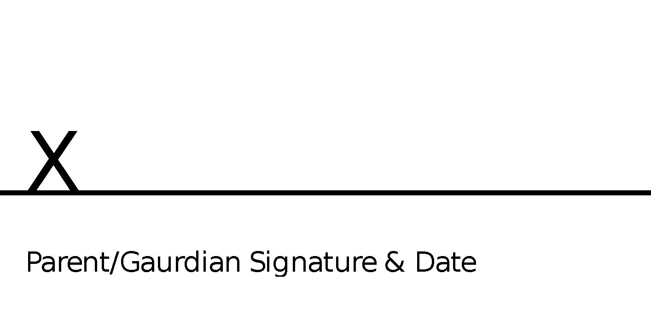

ASKA Code of Conduct
Karate Academy is committed to providing a safe, fun and learning environment by promoting respect, responsibility, discipline and excellence. As we know accidents and mistakes are prone to happen, therefore students will be guided to handle situations in a peaceful way. To ensure reaching these goals ASKA have set rules for students to follow. Students that react in disrespectful or violent manner will first be given verbal warnings.
In addition, we require each student to adhere to the Social Distancing standards in place to ensure the safety of each staff member and student. If a student is not adhering to social distancing standards, a “COVID-19 Non-Compliance Warning” will be sent home for review and signature.
Students that are given verbal warning but repeatedly offend with the same behaviors will be subject to the following disciplinary actions:

1st Offense – will result in a phone call to parent. No participation in group afternoon activities. Required to complete writing disciplinary assignment.

2nd Offense – will result in a phone call to parent for early dismissal. No participation in Friday activity or Parent’s Night Out.

3rd Offense – will result in early dismissal and parent conference or 1-day suspension from ASKA.

Final Offense – will result in parent conference and 2-days of suspension from ASKA. This may incur dismissal from ASKA Camp altogether with discretion upon the Director.

Please sign below to indicate you and your student(s) have read, understand and agree to the ASKA code of conduct.

Transportation Permission Slip
I, ________________________________ (Parent/Guardian Name) grant ASKA permission to transport my child(ren) listed below with the commercial vehicles under the supervision of ASKA employees to and from varied activities while attending Summer Camp for the duration of time between June 21 – August 27, 2021.

Child’s Name (Last Name, First Name) | Age | Car Seat Required – YES or NO

*Please note ASKA does not provide a car seat and you will need to provide a car seat for travel if one is required.
__________________________ _______________________
Signature of parent/guardian Date

Photo Release Authorization
I, ________________________________ (Parent/Guardian Name) grant ASKA permission to photograph my child(ren) listed below for ASKA property and use to advertise, promote and display the activities and events that take place while at ASKA (weather activities are on campus or off campus) for the duration of time between June 21 – August 27, 2021.
__________________________ _______________________
Signature of parent/guardian Date

